TITLE: SOZO ARTIFEX

NAME:EMMANUEL LEONARD GYINDO

REG NO:29724/T.2022

DATE OF SUBMISSION:29-04-2024

TABLE OF CONTENTS

Methodology

Task 1 Interface summary and screenshots

Task 2 Website development summary and screenshots

METHODOLOGY

Interface development; Figma App.

Website development; HTML and CSS.

TASK 1 SUMMARY

The task 1 including the development of simple interface, this interface is developed using Figma which its online displaying, Figma is very and important tool for the developments of different websites which are stored within your accounts, Figma is more important because it shows how different page of your interface interacts.

This is a description of Figma developments interface, use google chrome to download a Figma then create account with your emails after that open Figma page select your frame whether its Desktop or watch or whatever, this show how your work will be displayed and for page interactives we use prototype. The followings are the pages of the interface of my project;

This link show how interface is displayed but its online <https://www.figma.com/file/jp6bh1zEhUOXjcRDXmXjLr/Untitled?type=design&node-id=0-1&mode=design&t=Xq0Hqsuiav5hJNP7-0>

HOME PAGE

The home page is similar to that of the web this is created using frame to display, then write a text, the home page is a starting page of my website, this page determines everything concerning my websites also it attracts the users to continue viewing my websites and this is a screenshot of my home page of interface

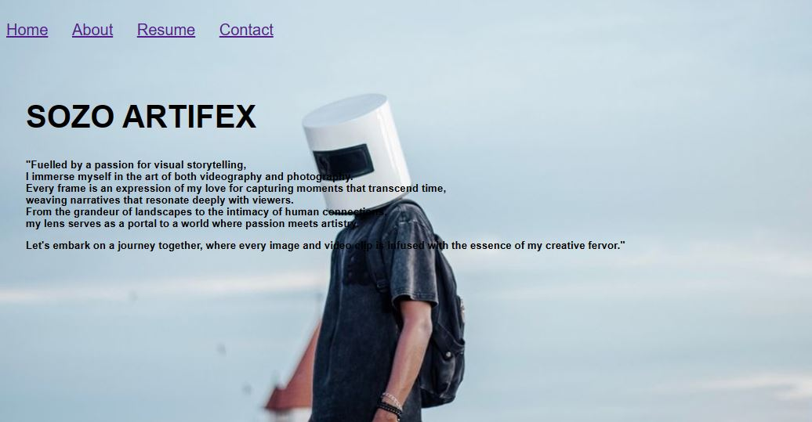

A screenshot of home page interface

ABOUT PAGE

This is a page that's talk about me it show my story through short summary of my work  
  
  
  
  
  
  
  
  
  
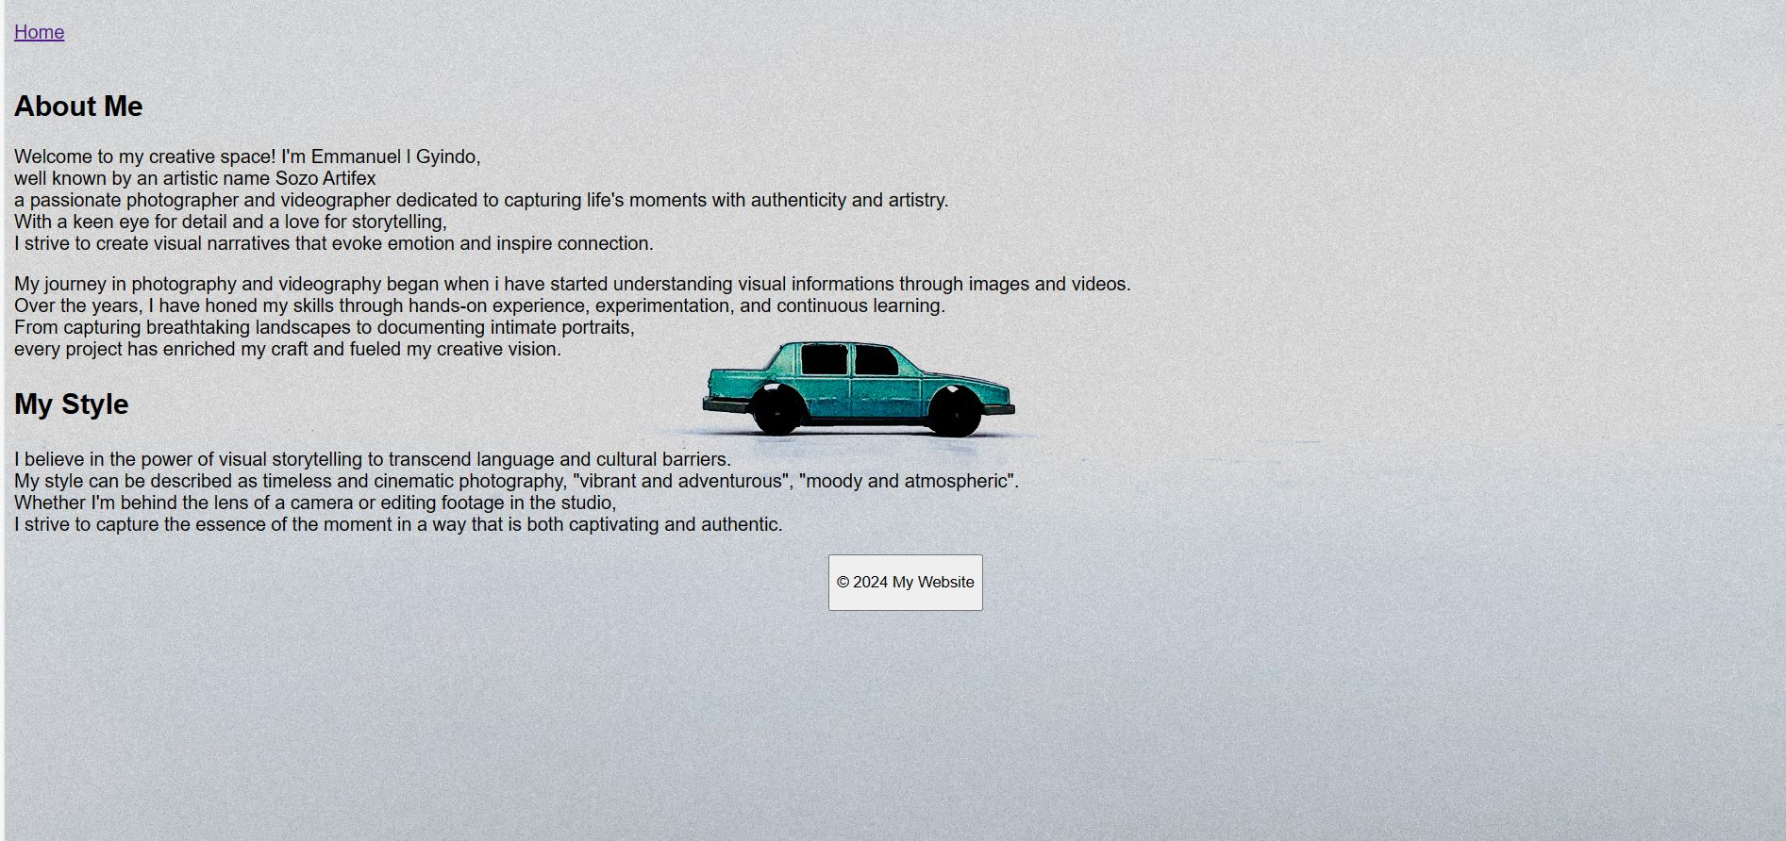

A screenshot of about page

RESUME PAGE   
 This is a page that shows my professional summary of my work

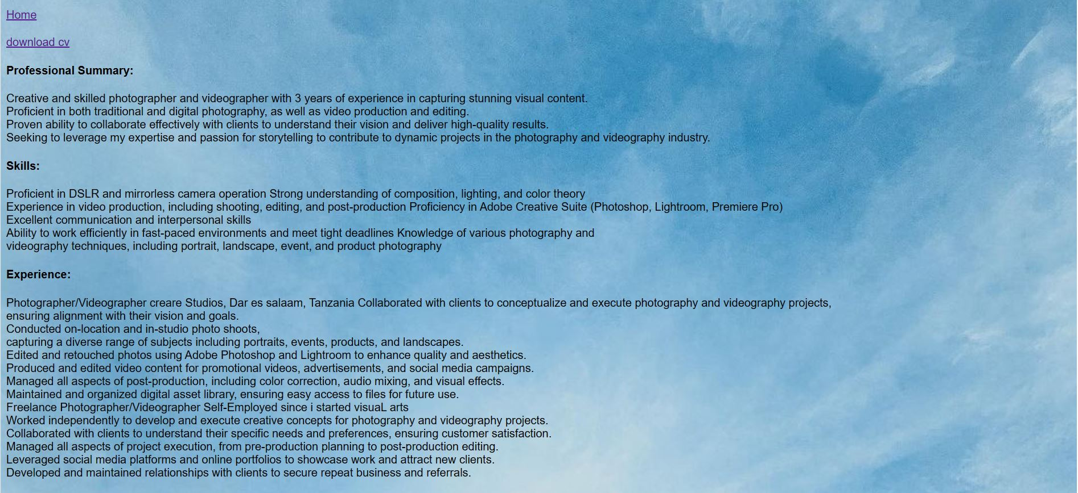

A screenshots of resume page

CONTACT PAGE

This page show my all contacts informations.



A screenshot of Interactivity

TASK 2 WEBSITE SUMMARY

The website development involves the process of coding where in coding we used HTML and CSS. By then it comes displayed with a browser and it can be Google Chrome or Firefox.

In website development, the developer must be most creativity in structuring and styling a web.HTML (Hypertexts markups Language) helps in structuring a web and CSS (Cascading Style Sheet) used to style a web work, hence someone must be competent based to develop better website

To develop a website, you must have visual studio code or sublime text in order to run the code of HTML and CSS and follow the structure of writing HTML also link CSS and HTML together () this is external level which is easier and good.

My Website including home page, about page, resume page these are navigation bars that are linked together with a linking code and are displayed inline. The following are their Screenshot;

HOME PAGE FOR BROWSER

A screenshot of homepage in browser HOME PAGE CODE

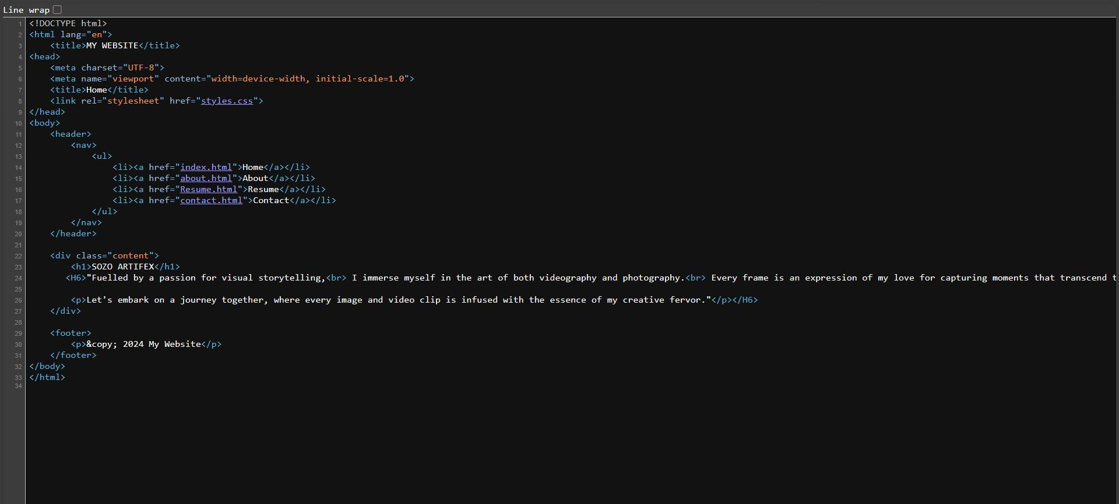

A screenshot of homepage sourcecode

ABOUT PAGE SOURCE CODE

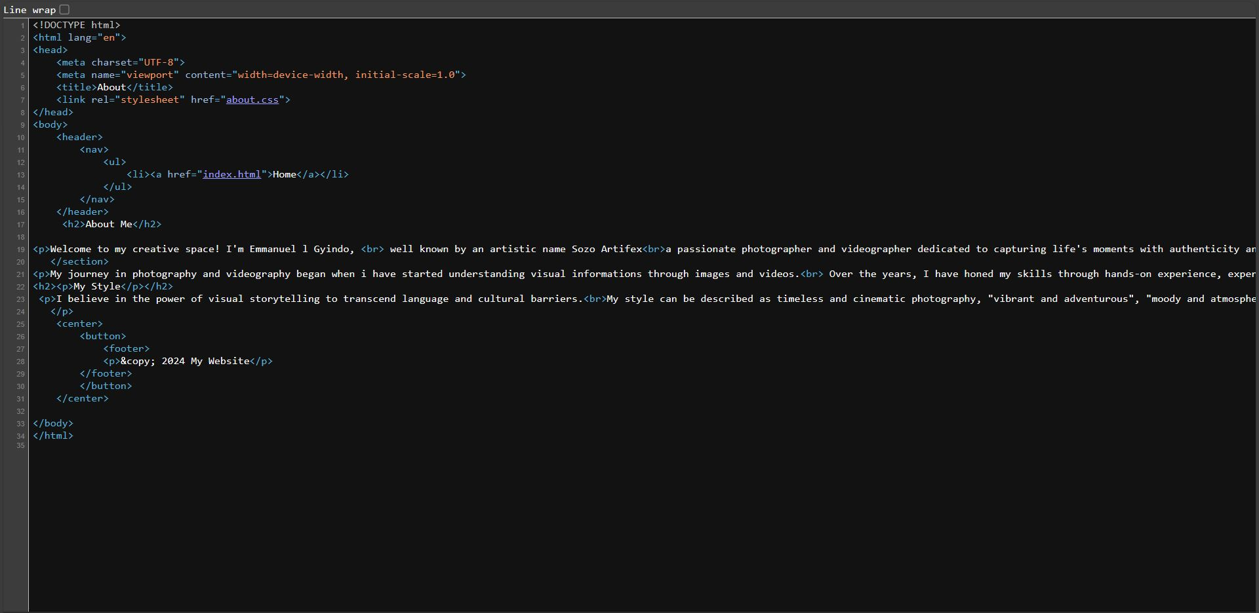

A screenshot of about page source code

RESUME PAGE SOURCE CODE

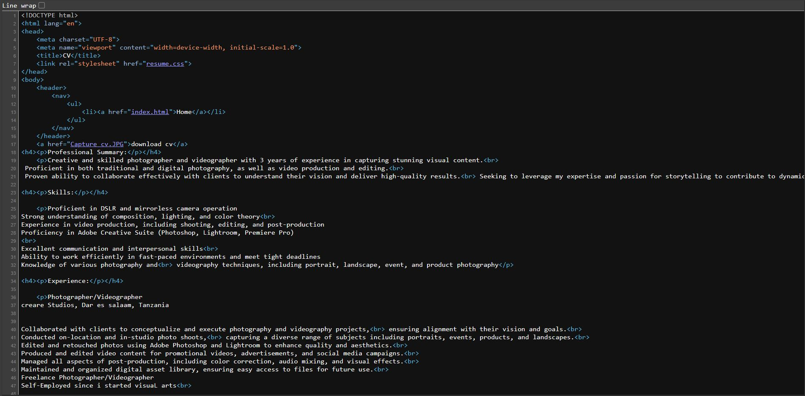

A screenshot of resume page source code

CONTACT PAGE SOURCE CODE

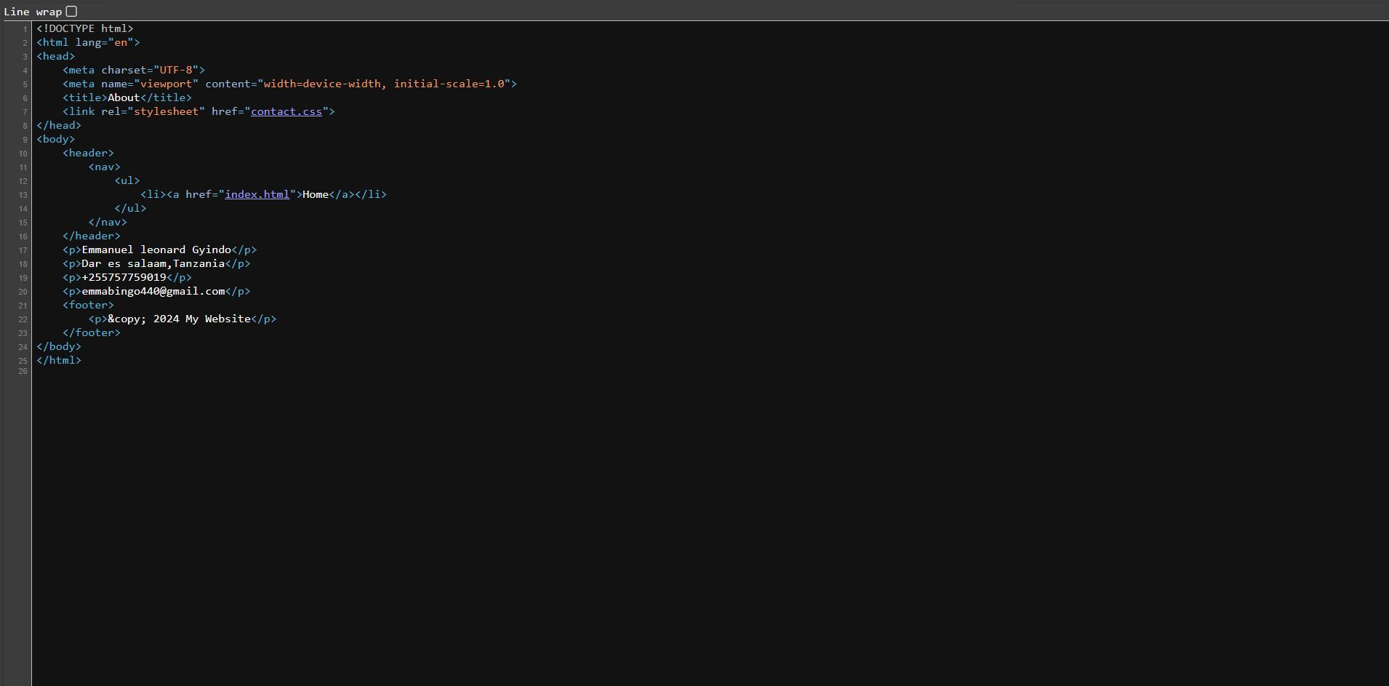

A screenshot of resume page source code

Generally; An interface and website development because enable a person to become creativity also develop deep knowledge on how to solve different problems concerning's about interface development or web developments also this enable an individual to be familiar with programming's and non-programming's languages, Practicing makes you perfect as much you come familiar with this issues you are going to solve a lot of problems that's faces our community